imatia.com 2011

Datasheet - CIVIDAS

Side 1: (Full bleed image)

Offering citizens more

Cividas is an e-Government Case Management platform that allows public administrations to streamline their internal processes, saving time and money. But it does more. It helps Authorities to stay ahead of legislation regarding e-Government by improving internal processing and providing a modern, easy to navigate public-facing web portal. This gives citizens more access to the services offered.

With Cividas, workflows, documents, application forms, integration with other systems and much more can be completed by anyone. There’s even a customizable version for Local Councils.

Side 2:

Save time, save money and so much more

We know cost saving is always a big priority and this has always been the driving force behind e-Government solutions. Cividas goes a bit further to deliver even more.

Our innovative, easy to adopt and powerful platform allows national, regional and local governments to streamline internal processes, making a range of tasks and functions easy to execute, monitor and refine whilst reducing bureaucracy and errors in the process. The cost-saving benefits of this are obvious, but there’s more to Cividas than simply great value.

Our e-Government tool helps Authorities deliver public services more effectively to the people who want and need them. With the minimum of implementation time and staff training, Cividas offers citizens the option to interact with public services over the Internet and via their mobile phones.

With the help of Cividas, national and local Governments can quickly and cost-effectively:

- Analyze internal processes
- Modify them to make them more efficient
- Simplify the interaction between citizens, suppliers and enterprises
- Automate work where possible
- Put staff in control and make their life easier
- Tailor process to their exact needs

Separate text box:

Cividas at a glance.
Electronic case management
Workflow & advanced forms
Document management (scan, store, generate)
Digital signature and invoicing
Physical and electronic registry
Follows a Service Oriented Architecture (SOA)

Also includes:
Customizable versions for local Councils.
Integration with other locally standard systems.
Flexible enough to be used to create innovative new solutions

More of the features you’re looking for.

Cividas is a full end-to-end solution that integrates all aspects needed for seamless, reliable and efficient e-Government.

Processes

Simple graphical process handling
Administrative staff can easily design and follow the process flow with a simple graphical interface that uses behind the standard XPDL format. Citizens can check the state of their processes using the same platform.

Simple case management
Once a citizen has made a request, Cividas gets to work helping internal staff manage the case efficiently and effectively.

Applications

Control your information
Each process is structured into different activities that administrative staff can define and perform using a graphical interface. This allows the user to associate with each activity, different kinds of applications (forms) that enable them to display information, capture data, perform calculations and generate documents etc. Form design is done in a simple and intuitive way, using a drag and drop interface powered by a predefined component library which, though very complete, can also be easily extended.

Documents

Process management – not document management
Unlike document management tools that simply track documents, Cividas tracks process and relates it to the real work that must be done.

Links

Designed to work with existing systems
As Cividas acts as the central coordinator of activities and information, it’s essential that it allows a simple and transparent interaction with other already existing applications or external services in use. This allows for a single point of access to public services and spares the users from having to access diverse applications or web sites.

Cividas options available:

- Cividas Basic
- Cividas Local
- Cividas Advanced
- Cividas Unlimited

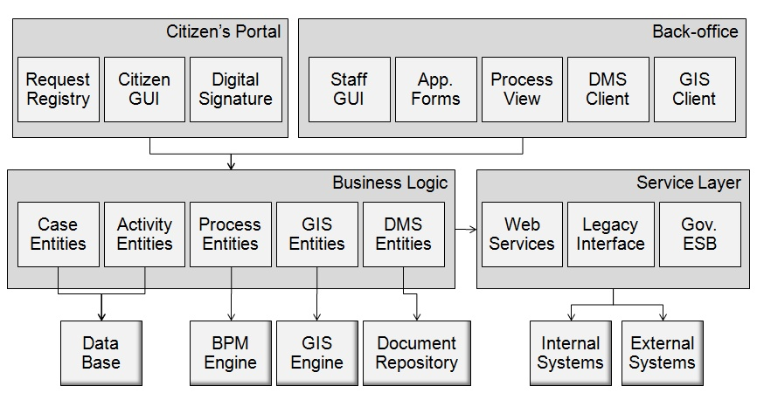

Contact details for further info

