imatia.com 2011

Datasheet - ONTIMIZE

Side 1: (Full bleed image)

More advanced software.
Less development time.

Ontimize is our leading developer-friendly software framework that allows forward-thinking companies to create impressive business software in no time. Robust, profitable and professional, this high-level Open Source Agile Development Framework builds modern Rich component based Internet Applications with the minimum of effort.

Ontimize gives you all the latest technologies and techniques for rapid interactive application development at your disposal, allowing you to create and deliver solutions that compete with the big players, but with much shorter lead times.

Ontimize at a glance
Desktop and mobile solution
Java Swing + Java FX
Webstart deployment
Comprehensive rich GUI
Not bound to a browser
Online/offline functionality
Component based architecture

Also includes:
Workflow Engine & Designer
Document Management Module
GIS, 3D.

Side 2:

Do more in less time

Ontimize makes great use of advanced high-level components, with an Open Architecture based on well-known standard technologies. The ideal solution for companies that don’t have the time or resources to develop and maintain their own software, Ontimize gives you all the tools you need to create impressive Rich Internet Applications for the desktop, browser and mobile environments with minimum investment and effort, and maximum ROI.

Ontimize high-level framework gives you:

* Cross-platform support
* A modern Rich Interactive Application interface
* A network design optimized for the Internet
* Ease of use plus ease of customization
* Increased productivity without sacrificing flexibility
* Increased development speed and consistency by reusing code and patterns

With the ability to create impressive software applications, and get these to market quicker, the competitive advantage is clear. As well as the increase in speed of development, the reliability of the framework allows you to create applications that won’t let you, or your customers down. Utilizing the best-proven technologies, refined and tested at our own facility, our framework is always up to date so you can always create more competitive solutions.

Features and benefits.

- Java based - Cross-platform support without rewriting code
- XML definition files – this declarative approach clearly defines what is needed
- Component based architecture - easy to add, extend and integrate with existing services
- For desktop and mobile – allows for seamless integration as application environments continue to evolve
- Eclipse plugin – enables industry standard fast development
- Basic user authentication using LDAP, Kerberos, SSO and more – offering comprehensive security support from a single log on.
- Comprehensive set of widgets and controls - tables, trees, links, file attachments, image fields and more all directly available
- Standard client logic - validation, search, insert, updates without any coding
- Automation of basic CRUD (Create, Retrieve, Update and Delete) operations – robust data control without coding
- Efficient communications - with intelligent bandwidth management
- Rapid prototyping - delivered by automating high-demand user functionality

Ontimize – the perfect solution for you

ONTIMIZE Standard Edition
Ideal for small and medium sized applications, our SE version does not require a Java EE server, has a standalone capability, automated installations and more.

ONTIMIZE Enterprise Edition

The Enterprise Edition is the ideal solution for large applications and systems, leveraging all the power of the Java EE architecture while providing a very rich interface based on Java Swing.

ONTIMIZE More
A collection of advanced components including: dynamic tables, graphical Information Systems, document management and more. Ontimize More is only distributed with Ontimize EE.

ONTIMIZE Micro Edition
The Ontimize solution for mobile and other embedded devices. It is based on the Java Micro Edition (Java ME) and integrates with the Ontimize Standard and Enterprise Editions.

ONTIMIZE Web Faces
Ontimize Web Faces provides browser-based user interface on a combination of AJAX and Java Server Faces technologies.

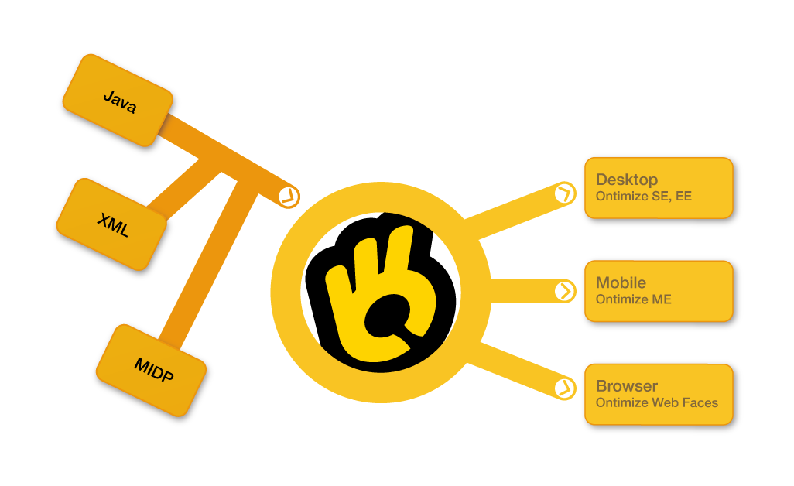
What engineers say.
“Ontimize is easy to use and easy to customize.”
“It increases productivity without sacrificing my flexibility.”

What IT managers say.
“We’ve seen a notable improvement in software quality and reliability.”
“Ontimize increased the motivation and sense of achievement of my engineers.”

Ontimize success story – Network Rail

Network Rail owns and operates Britain's rail infrastructure of more than 2500 stations, around 1.2 billion passenger journeys a year.
With an Ontimize based solution, Network Rail efficiently manage all the 4 million + relays that form essential circuits for signalling and electrification control systems. Periodical inspections, work orders to fix or replace and all information can be monitored successfully.

